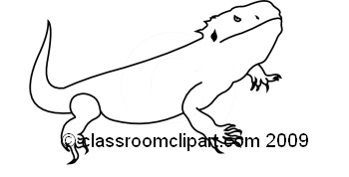
Introducing Ziggy!

This week you met our class pet! He is a bearded dragon, or a “beardie,” as they are often called. He is friendly and chill and loves attention from everyone, but will probably need some time to adjust to seeing 100 people a day after a quiet summer. Beardies will almost never bite or purposely scratch. However, they do have clawed feet that might snag on clothing or leave small scratches.

If you would like to pet him, or hold him, or feed him you need to do so with my supervision. If you come in before or after school with friends who would like to hold, pet, or feed him, they will need get one of these forms signed first.

Beardies are fascinating lizards, and I hope that you will enjoy getting know ours this year.

Note to parents:
The students and I love having a class pet. There are many ways to introduce pets into any subject, from poetry and short stories to nonfiction and grammar. I hope that our bearded dragon will be a valuable addition to our classroom.

Bearded dragons are cold blooded, so any parasites or diseases that a dragon may carry cannot survive in our warm blooded bodies. The one exception to this is salmonella. However, the chance of contracting salmonella from a reptile is extremely low, especially if one washes one’s hands before and after handling it. In fact, according to the Center for Disease Control, humans are much more likely to contract salmonella from food we eat than from contact with reptiles. However, at-risk populations (such as children under five or persons who are immunocompromised) should avoid handling our bearded dragon or other reptiles.

Because you know your student’s health concerns better than I do, if your student wants to hold or pet our beardie, he or she will need your permission to do so. Please take a moment to fill out this form so that when your student asks to hold our beardie, I know they have your approval to do so.
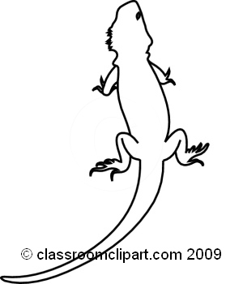
Student Name: __________________________________________________________

Parent/Guardian Name (Please Print): ________________________________________________

[ ] My student has permission to pet/hold/generally adore our beardie.

[ ] I would prefer my student not handle our beardie in any way.

Signature: _____________________________________________________________

Comments: ________________________________________________________________________________________________________________________________________________________________________________________________________________________________________

